*4thInternational Conference on Internet of Things (ICIoT 2023),*

*SRM Institute of Science and Technology, Chennai, April 26-28, 2023.*

**An efficient IOT based Autonomous Robot Technology for Farming**

**Krithika Vaidyanathan1,*, Nandhini Murugan2, Anithakumari S****ivathanu3,** **Dharmarajan Elangovan4,** **Arun Boniface5,** **Praneesh Kumar6**

1,2,3,4,5,6Department of Mechatronics Engineering, SRM Institute of Science and Technology, Kattankulathur, Chennai, India, 603203

*Corresponding author Email: [krithikv@srmist.edu.in](mailto:krithikv@srmist.edu.in)

**Abstract**

Digital farming is the use of modern technology such as sensors, robotics, and data analysis to automate tasks that farmers formerly performed. This study focuses on a semi-automated vehicle capable of ploughing, seeding, and water irrigation, which is one of the most recent agricultural robotics accomplishments. Object detection in a route in the context of automated farming. Concerns include programming algorithms and enhancing sensor performance. Digital agricultural gateways, Multi-Functional Vehicles, Humanoid Robots, aerial photographs, and ground-based sensors for creating virtual farms were all examined as possibilities. One of the hottest technologies and research issues in the agricultural area is the creation of a swarm of tiny robots and drones to work with farming inputs and reveal previously hidden or denied data. In the instance of automated robot farming, automated programming with a function might be faster and more efficient than the existing professional. Despite the fact that robots and farming are merging, an automated agriculture system has to be accepted as true, which will not be deployed anytime soon.

Keywords— farming, Automated robot, water irrigation, IoT, ploughing, seed sowing

# Introduction

Agriculture is a key industry in the development of human civilization. Over time, it is has been witnessed significant changes in the agricultural sector as a result of the introduction of new technologies leading to the growth of the global agricultural market. Robotics is the branch of technology that deals with the design, construction, operation, and application of robots, as well as computer systems for control, sensory feedback, and information processing [1]. The system that can perform agricultural work without human intervention is the need of today's world. This type of intelligent system has a robust and workable model with several functions that is the need of the future in all fields of technology [2]-[3]. Precision agriculture plays an important role in the agricultural sector to meet the needs of the agricultural industry and the food industry [4]-[5] Agriculture is an expensive and extremely wasteful industry. The precision farming movement may not solve all of the problems facing the industry, but it has the potential to improve sustainability and efficiency [6]. Previously, precision farming equipment was only available in the form of heavy machinery [7]-[9]. Hence the automated robot system brings precision farming technology to environmentally conscious people [10]-[12]

Automation is a technique, method, or system for regulating or operating a process with minimum human involvement using highly automated means, such as electronic equipment [13]. It is the design of any system made up of individual components that may be linked together. The benefit of modular design is that any single component (module) may be replaced or added without impacting the rest of the system [14]. In the realm of digital electronics and intelligent systems, robot-assisted automation has become one of the world's fastest-growing application-based technologies. Users may now operate their farms (for example) from afar using a mobile application on their phone thanks to the integration of mobile communication technology into automation system [15]. The objectives of this work are as follows; to make the farming robot do the basics activity like Ploughing, Seed Sowing, irrigation and closing the Ploughed field and then implementation of IoT. Robots can be controlled by both Autonomously and Manually using Android apps. To build an automated farming robot using Arduino and IOT based controllers for the process of operations. Farming will be made easier to do, and the majority of people will profit. This Robot is beneficial to those who do not have the energy or strength to work [16]-[18].

# METHODOLOGY

A brief questionnaire about agricultural robots was created using a Google form, and responses were collected from the general public. According to the results of the survey technique, the majority of people are ignorant of the usage of robots in agriculture. This facilitated to frame the objective to build and develop automated farming robots that can do basic agricultural jobs.

The proposed robot (iFarm robot - IoT Based Automated Farming Robot) has an electric motor system, two main wheels, two Omni wheels, and a control unit on top, and it can go between rows without touching them. Also, it can turn at the end of the row, and enter the next one. An ultrasonic sensor uses sonar to detect the distance to an object. The Arduino MEGA serves as the main control unit, interpreting sensor data, modifying motors based on that data, and controlling the robot. A DC motor card drives the motors, allowing the control card to control the robot.

In the proposed automatic robot, the seeds are placed in the funnel, tank contains the required water. By the way of robot movement, the front hook ploughs the field. The servo motor is provided to assist in seed falling mechanism. Since the funnel is filled with seeds, they fall one by one onto the ploughed field. The water is pumped from the tank using a submersible pump. Fins in the back will close the ploughed field. This may be done automatically by the Arduino MEGA, or manually using the mobile app. Solar panels may be used to automatically charge batteries. The robot can turn itself using an ultrasonic sensor. With the help of the Blynk platform, user interface is created for managing and controlling the hardware setup from mobile devices. The sensor data or switch on and off pins can be shown using the widgets.

# Design of proposed iFarm Robot

## Design of Hardware components using Solidworks and 3D printing

The ifarm robot is designed using SolidWorks. Initially chassis and wheel for bot was designed and then the water tank were designed. Later, the funnel for seed falling has been designed. The designing of vehicle upper part is done primarily and after completion of upper part, the design of lower part components such as seed falling stage, placement of motor, servo motor, seed plate and spring were carried out. Once modelling of all the parts were done, assembling the final robot is done. The design of all the parts are shown in Fig. 1,2,3 and 4.

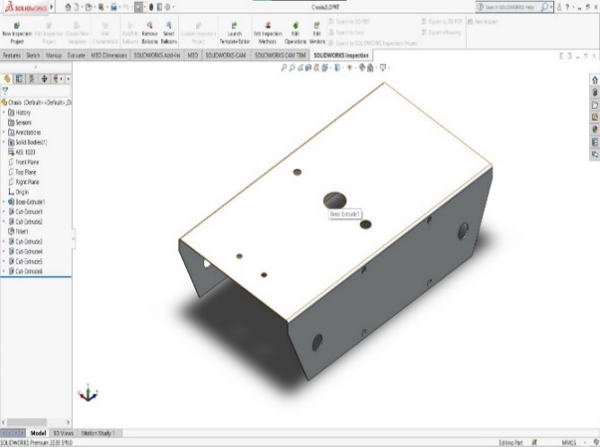 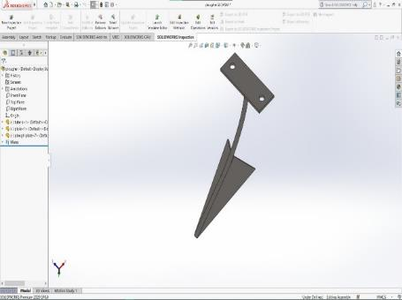

Fig .1. Chassis Design in SolidWorks Fig. 2. Hook Design in SolidWorks

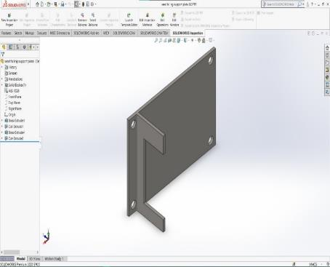 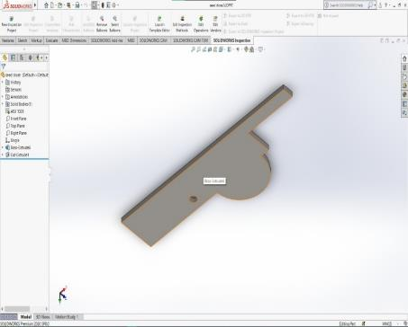

Fig. 3. Seed Falling Part Design in SolidWorks Fig. 4. Seed Dispensation Part Design in SolidWorks

## Electrical Design

The main component in this work is Arduino Mega 2560. It is a Microcontroller used to control DC Motor, Servo Motor, Sump Motor and Ultrasonic Sensor. Also, this Node MCU which acts as Wi-fi Module for the robot is connected. This Microcontroller was selected because it has 54 digital input pins and 16 analog input pins because while using Motor Shield, extra pins are required to connect. Also this controller has more features and capable of controlling more sensors at same time. Arduino Motor Shield is used to control the speed and direction of motor. This Motor shield is capable of controlling four dc Motors/ two servo motor at same time. In this, work two dc motors, one sump motor and one servo motor are used. Node MCU is a Microcontroller which is generally used in IoT applications as Wi-fi Module. For the same reason Node MCU is used as Wi-fi Module which is integrated with Arduino Mega 2560. Blynk App is used to communicate (Input) from mobile to Arduino via Node MCU.

Humidity sensors work by detecting changes that alter electrical currents or temperature in the air. The DHT11 is a Humidity and Temperature Sensor that outputs an accurate digital output. This sensor can connect to any embedded device, such as an Arduino or a Raspberry Pi, and provide quick results. This sensor is a very affordable humidity and temperature sensor with a protracted endurance and sustainability.

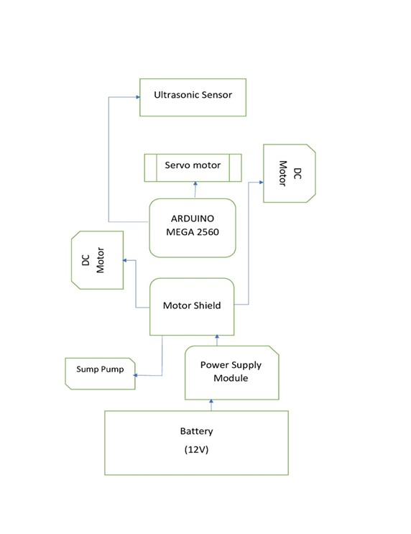

Fig. 5. Schematic representation of the proposed robot electrical circuit setup

It includes a responsive temperature sensor to analyze the air flow and then gives the modular signal from raw to digital data on the data pin (no analogue input pins needed). The pull up resistor is necessary to utilize the DHT11 sensor is included in this module, making it very basic to connect. To utilize only three connections are required such as; Vcc, Gnd, and Output and this has a level of reliability and may be used for a long period of time. The Fig. 5 and 6 represents the electrical circuit setup of the proposed robot system.

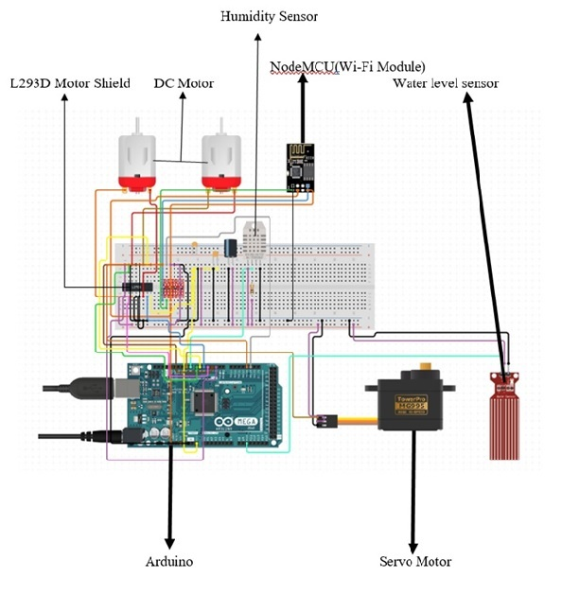

Fig.6. Schematic Diagram of electrical connections of the proposed robot

To achieve the purpose of movement, Johnson Motor Gear 12V,500 rpm is used and also this motor is very suitable for robot with some Load. Two motors are used to achieve both right and left side movements, one in front (for right side) and another one in back (for left side). For sowing seeds on field, the sump motor (Submersible Mini Water Pump) is used in irrigation. The Servo motor MG996R is used for Seed Falling/Sowing Mechanism. The exertion of this motor is to move seed filter plates with given time delay. So, that seeds fall from funnel to the ground and it is also used to prevent the seed from falling at a time.

The plastic tire wheel is the one utilized in the proposed iFarm robot chassis. A four-wheel and castor wheel chassis was used. Four wheels make it easier for the chassis to support the components and allow them to move freely. In this robot only two motors are used for the back wheels for turning Forward, Reverse, Right and Left. The battery used is 12 V 1.3Ah Lead Acid Rechargeable Battery which weighs 0.5kg.

## Fabrication of iFarm Robot

The proposed iFarm robot is inspired by self-driving cars, and we intend to utilize it in farming. So, using Arduino and Node MCU, a robot is built that will be monitored and controlled by a mobile device. For monitoring and movement purpose, sensors, motors, and motor shields were employed. The tasks that are performed by the designed iFarm robot are ploughing, pouring water and seed sowing. The entire design of the proposed iFarm robot is shown in Fig. 7.

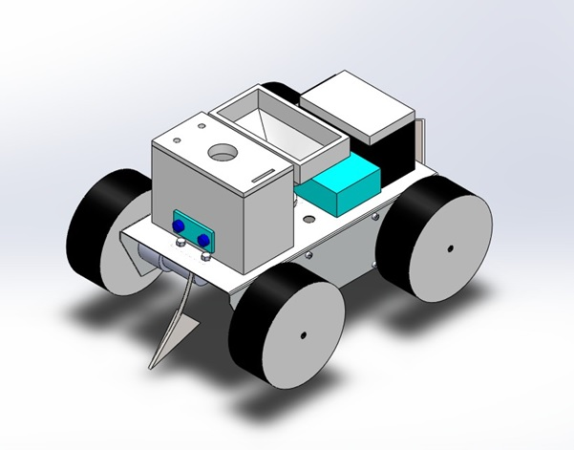

Fig. 7. Design of proposed iFarm Robot

The design of Seed sowing mechanism is done using SolidWorks. After completion of design, 1 mm sheet was bought and bended using shear stress bender and drilled holes in marked points. Then, the parts were welded using TIG welding. A 250x250mm plane steel sheet with a thickness of 1mm was delivered. The sheet was folded as (250x130x60) per the 3d model, and the chassis was built. The holes for the motor installation have also been changed according to the 3D model. holes for the funnel, water tube, and wiring, as well as the plougher mounting, all of which were created according to our 3D model. This plough is used to prepare the land for sowing. It was created out of 2mm SS sheet (40x15) and 3mm rod (L-90) and a 1mm sheet, according to our 3D model (55x40).The fabrication process explained are shown in Fig. 8.

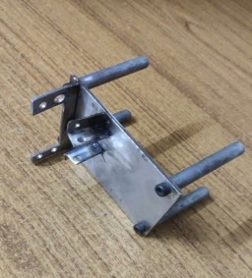 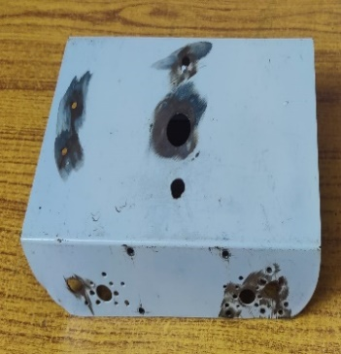 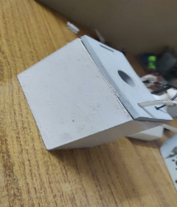 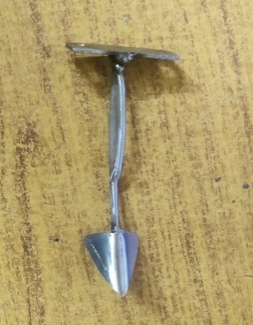

Fig. 8Fabricated set up of seed Falling Stage, chassis, 3D printed tank, hook for ploughing

## Seed Falling Mechanism

For the seed sowing process, a mechanism was developed which contains two metal plates. The pieces on one side of the plate are connected to the spring and the other side was fitted with a metal plate stage as shown in Fig. 9. With the help of servo motor two plates are pressed by a leaf which was connected to the motor to release the seed from the funnel.

At the initial stage, the servo motor will be at 90 degrees as shown in Fig. 10. Once the servo receives the power it will run to 20 degrees and moved to 160 degrees. During this process, the seed will fall from the funnel to the ground.

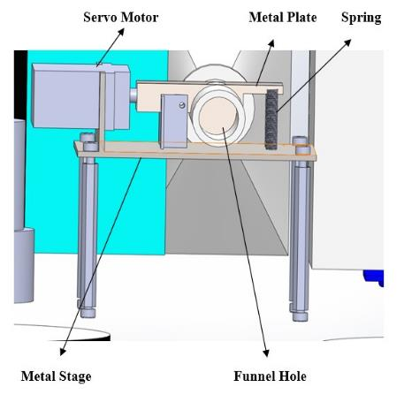 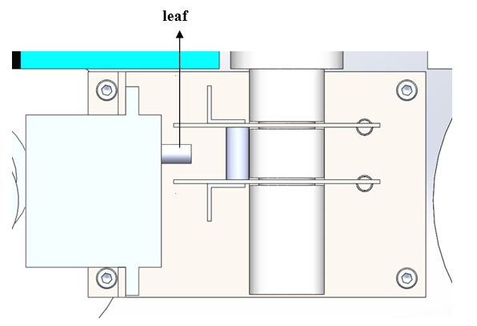

Fig 9. Seed Falling Bottom View Fig. 10. Seed Falling Plate Side View

## Fabrication of Tank and Funnel

Water Tank was made by PLC filament with the help of 3D printer. Capacity of tank was 500ml. With the help of this tank, we can store irrigation water. Inside of the take we fixed sump motor which will bring the water to ground (Fig. 11). To control water leakage, the tank is painted with white paint.

Funnel was made by PLC filament, which was connected above the chassis. The seeds can be filled inside the funnel which will drop one by one to the ground as we programmed and seeds will fall on the ground at specified intervals (Fig. 12).

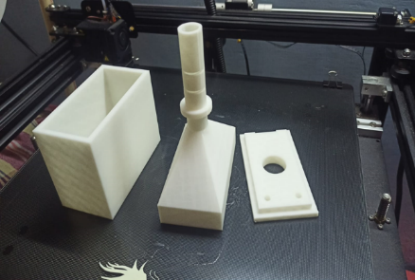 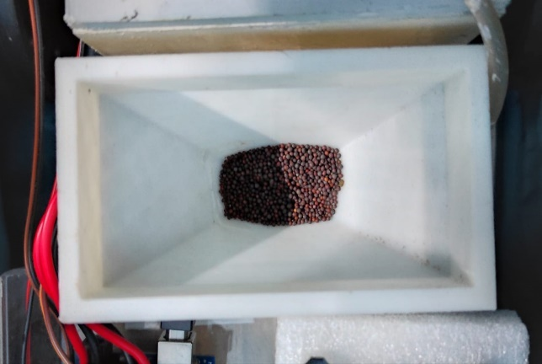

Fig. 11. Fabricated model of Tank and Funnel Fig. 12. Top view of Funnel with seed

## Experimental setup for robot design

For developing and transferring code to Arduino boards, there is an open-source program called the Arduino IDE. Microsoft, Apple OS X, and Linux are just a few of the operating systems that the IDE program is compatible with. Programming languages available include C and C++. In this instance, IDE refers to Integrated Development Environment. Writing code or a programme in the Arduino Software is referred to as sketching. We must interface the Genuino and Arduino boards to the IDE in order to upload the sketch created in the Arduino IDE programme. The drawing is saved using the '.ino' extension.

In blynk app we created interface named as seed sowing robot(Fig. 13). In that there are three sections named as mode, seed and water, movement. In mode section we can choose between two modes either automatic or manual. In Seed and water section we can control Seed sowing and water irrigation. In movement section, it has 4 buttons named as M1, M2, M3 and M4. With the help of these 4 buttons, we can control the movement of the robot by pressing the two button together.

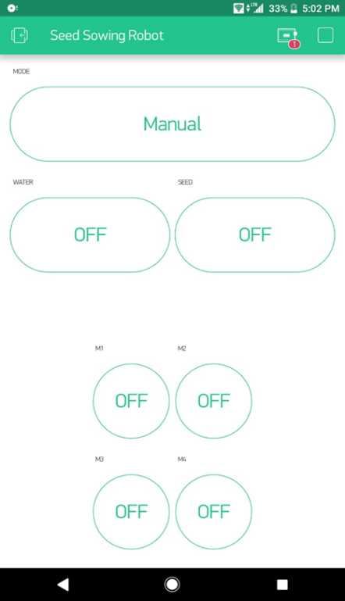

Fig. 13. Screenshot of Blynk App Interface to control the robot

SolidWorks is a 3D modelling CAD software used in the development of mechatronics systems from the first stage to the final one. It is utilized for initial feasibility analysis, product development, scheduling, visual ideation, modelling, prototyping, and feasibility evaluation. The design and construction of mechanical, electrical, and software components is then done using the program. Eventually, it may be used to monitor cloud services, analytics, devices, and data automation. SOLIDWORKS software solutions are used by experts in mechanical, electrical, and electronic design to provide an integrated design. The suite of tools is intended to keep all professionals informed and prepared to act swiftly on requests or changes to designs. The Fig. 14 represents the side view of the iFarm robot.

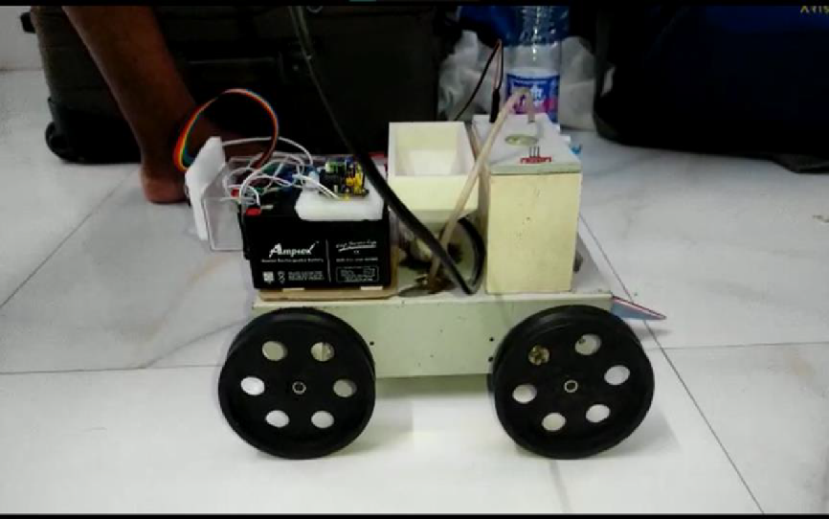

Fig. 14 Side view of iFarm Robot

# RESULTS AND DISCUSSION

Farmers have found this initiative to be quite beneficial in terms of saving energy and time. According to investigation into various research publications, there is no comprehensive robot for ploughing, sowing, or irrigation in the early stages of farming. As a result, this robot is designed to include all of the aforementioned characteristics in order to make it as efficient and energy-efficient as possible.

As a result, in the beginning stages of farming, this single robot may be utilised for ploughing, seeding, and watering. Also, as per the objective, the prototype was built to function in both manual and automatic mode.

## Testing of designed robot

The program was made to control the bot in two ways, namely Automatic and Manual. Initially the bot runs in Automatic control mode. This mode runs with open loop function and checks the working condition such as bot movement, seed falling and water dropping. The bot now stops. At this instance, the user has provision to choose the mode of control (automatic or manual). If the user chooses the automatic mode, the bot moves Forward for 5 seconds and stops. After 2 seconds delay, Seed falling will happen for 2 seconds. Again after 2 seconds delay, water will start to drip for 3 seconds. The process starts after 10 second’s delay. During this process if any object is detected through ultrasonic sensor, the bot takes left turn by default (even though this if it is in online mode) as shown in Fig. 15. If user selects manual mode, the bot will wait for response from blynk app. Here user can control Bot through commands provided in Table 1.

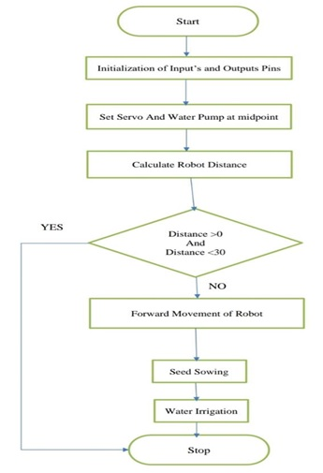

Fig. 15. Workflow of iFarm robot

## Functioning of the iFarm robot

Blynk App is used to control the prototype. Bot will go forward if both M1 and M2 buttons are pressed. The buttons M3 and M4 should be hit to propel the bot backward. M1 and M3 buttons are pressed to move the bot left, and M2 and M4 buttons are hit to move the bot right.

SEED and WATER are two independent buttons for seed falling and water flow. There are two modes to choose namely; automatic and manual. The open-loop function will be run in automatic mode. The Bot will initially travel forward for 5 seconds before stopping, after which the servo motor will operate for 3 seconds, triggering the seed dispensing plate. The seed will fall from the funnel during this procedure, and after a 2-second wait, the sump motor will operate for 5 seconds, bringing water from the tank, followed by a 10-second delay. The process will repeat itself.

In Manual Mode, the bot may be controlled by inputting instructions using the Blynk app as seen in Table 1.

1. Buttons and Movement

|  |  |
| --- | --- |
| Buttons | Movement |
| M1,M2 | Forward Directions |
| M3,M4 | Backward Directions |
| M1,M3 | Left Directions |
| M2,M4 | Right Directions |

A hook beneath the chassis at the front half of the vehicle is installed to plough the ground for seed planting. Only the hook will be manually handled. The Seed Sowing Mechanism is positioned beneath the funnel in Fig. 16. The constructed Seed dropping stage has been installed beneath the chassis. The servo motor is then positioned at the stage of seed dropping. Then, at this position as shown in Fig. 17, the designed Seed plate and Spring are joined.

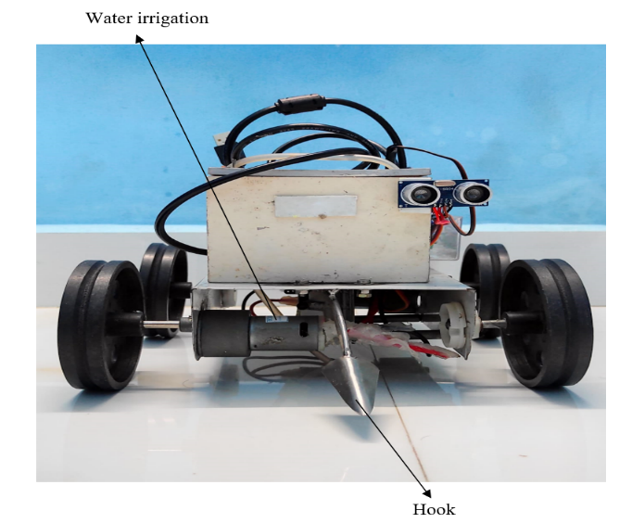 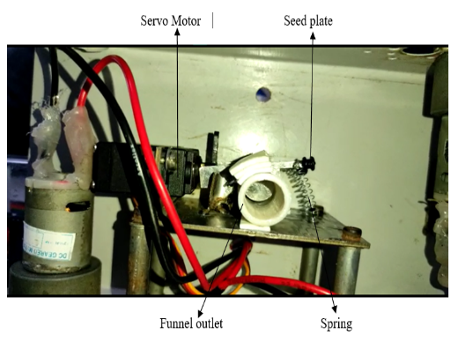

Fig.16. Front view of iFarm Robot Fig. 17. Seed Fall Mechanism

## Future Scope

In future, some functionalities can be expanded which will improve and optimize the performance of the robot. The movement of vehicle can be changed from normal drive to belt drive mechanism. Also, for charging battery a solar panel can be added. In addition to it, for Ploughing tool Adjustment servo motor can be included so that it can plough uneven lands easily without any disturbances. The range of transmitter can be increased so as to apply this iFarm robot in large field farming.

# CONCLUSION

This work aimed and achieved to develop an Automated Farming Robot using Arduino. According to the first findings of this research, most autonomous systems are more adaptable than traditional systems. Reduced labor expenditures and constraints on the number of daily working hours improved the situation greatly. As a result, the most important working processes can now be automated. The work proposes a low-cost, low-power, and simple device control system. This system will be useful in agriculture, gardening, and Agri university. The chassis supports the entire weight of the water tank, hardware and battery put on iFarm robot, allowing it to do each and every action with expertise and success.

##### References

1. Kiran Kumar B M , M S Indira, Nagaraja Rao Pranupa S, “ Design and Development of Three DoF Solar Powered Smart Spraying Agricultural Robot” , 27 March 2020,Volume 83, pp 5235 – 5242.
2. B.Srinath , Rutveez Roopam Rout, Vishal Bisht, Shubhankar Bhardwaj, A. Maria Jossy,“Automated Farming Bot”, April 2017, Volume 7 Issue No.4,pp -10638 – 10640.
3. Sujata Bhosale, Asha Biradar, Kanchan Meshram, P.R.Patil, “Agricultural Automation Robot using Arduino”, March 2018, Volume 3 Special Issue 1, pp 139 -141.
4. Amol Gothankar, Vishal Son, Avinash Vishwakarma, Sagar Jankar , Satish Bhoyar , “Automatic Multipurpose Agribot Using Arduino Mega and GPS Module Receiver”, April 2021, 760 – 768.
5. S Kautsar, E Rosdiana, B Widiawan , D P S Setyohadi , H Y Riskiawan and R Firgiyanto , “Farming Bot: Precision Agriculture System in Limited and Based On Computer Numerical Control (CNC)”, doi:10.1088/1755-1315/411/1/012059, Second International Conference on Food and Agriculture, 2019
6. Wolfert S, Ge L, Verdouw C, Bogaardt M J. Big data in smart farming –A review. Agric. Syst., 2017; 153: 69–80.
7. Chlingaryan A, Sukkarieh S, Whelan B., “Machine learning approaches for crop yield prediction and nitrogen status estimation in precision agriculture: A review”, Computers and Electronics in Agriculture, Vol 151, July 2018,Pages 61-69, ISSN 0168-1699, https://doi.org/10.1016/j.compag.2018.05.012.
8. Shamshiri R R, et al. Research and development in agricultural robotics: A perspective of digital farming Vol. 11 No.4 11 agriculture: A review. Comput. Electron. Agric, 2018; 151: 61–69.- 54
9. Oberti R, Marchi M, Tirelli P, Calcante A, Iriti M, Tona E, et al. “Selective spraying of grapevines for disease control using a modularagricultural robot”, Biosyst. Eng, 2016; 146: 203–215.
10. Bloch V, Degani A, Bechar A, “A methodology of orchard architecture design for an optimal harvesting robot” Biosyst. Eng. 2018; 166:126–137
11. Shamshiri R R, Hameed I A, Karkee M, Weltzien C. “Robotic harvesting of fruiting vegetables: A simulation approach in V-REP, ROS and MATLAB”, Proceedings in Automation in Agriculture-Securing Food Supplies for Future Generations, 2018, InTech.
12. Longo D, Muscato G. “Design and simulation of two robotic systems for automatic artichoke harvesting”, Robotics, 2013; 2(4): 217–230.
13. Shamshiri, Redmond & Weltzien, Cornelia & Hameed, Ibrahim & Yule, Ian & Grift, Tony & Balasundram, Siva & Pitonakova, Lenka & Ahmad, Desa & Chowdhary, Girish. (2018). Research and development in agricultural robotics: A perspective of digital farming. International Journal of Agricultural and Biological Engineering. 11. 1-14. 10.25165/j.ijabe.20181104.4278
14. Aishwarya, B., G. Archana and Chandrahasan Umayal. “Agriculture robotic vehicle based pesticide sprayer with efficiency optimization.” 2015 IEEE Technological Innovation in ICT for Agriculture and Rural Development (TIAR) (2015): 59-65 .
15. De Baerdemaeker J, Munack A, Ramon H, Speckmann H. Mechatronic systems, communication, and control in precision agriculture. IEEE Control Syst, 2001; 21(5): 48–70
16. Das, Jnaneshwar ; Cross, Gareth ; Qu, Chao et al. / Devices, systems, and methods for automated monitoring enabling precision agriculture. 2015 IEEE Conference on Automation Science and Engineering: Automation for a Sustainable Future, CASE 2015. IEEE Computer Society, 2015. pp. 462-469 (IEEE International Conference on Automation Science and Engineering).
17. Kanhaiya Kumar, Lokesh Varshney, A. Ambikapathy, Vrinda Mittal, Sachin Prakash, PrashantChandra, Namya Khan, “Soft computing and IoT based solar tracker” , International Journal of Power Electronics and Drive Systems (IJPEDS), Vol. 12, No. 3, September 2021, pp. 1880-1889, DOI: 10.11591/ijpeds.v12.i3.pp1880-1889
18. A. R. Syafeeza, M. K. Mohd Fitri Alif, Y. Nursyifaa Athirah, A. S. Jaafar, A. H. Norihan, M. S. Saleha, “IoT based facial recognition door access control home security system using raspberry pi” ,International Journal of Power Electronics and Drive System (IJPEDS) Vol. 11, No. 1, March 2020, pp. 417-424, DOI: 10.11591/ijpeds.v11.i1.pp417-424.